Sumit Vadaviya

Camunda BPM Expert, Corporate Trainer

Email : sumit.vadaviya@trainosoft.com

I

n this session we will configure camunda maven templates(archetypes) with Eclipse IDE. Camunda provide several project templates for Maven, which are also called Archetypes. They enable a quickstart for developing process applications using the Camunda BPM platform.

Camunda Maven Project Templates(Archetypes)

)

**Available Camunda Maven Templates**

| **Archetype** | **Description** |
| --- | --- |
| Camunda Cockpit Plugin | Plugin for Camunda Cockpit, contains REST-Backend, MyBatis database query, HTML and JavaScript frontend, Ant build script for one-click deployment |
| Process Application (EJB, WAR) | Process application that uses a shared Camunda BPM engine in a Java EE Container, e.g. JBoss Wildfly. Contains: Camunda EJB Client, Camunda CDI Integration, BPMN Process, Java Delegate as CDI bean, HTML5- & JSF-based start and task forms, configuration for JPA (Hibernate), JUnit Test with in-memory engine and visual process test coverage, Arquillian Test for JBoss AS7 & Wildfly, Maven Plugins or Ant build script for one-click deployment in Eclipse. |
| Process Application (Servlet, WAR) | Process application that uses a shared Camunda BPM engine in a Servlet Container, e.g. Apache Tomcat. Contains: Servlet Process Application, BPMN Process, Java Delegate, HTML5-based start and task forms, JUnit Test with in-memory engine, Maven Plugins or Ant build script for one-click deployment in Eclipse |
| Camunda Spring Boot Application | Application that uses the Camunda Spring Boot Starter. Contains: Spring Boot Process Application, Camunda Webapps, BPMN Process, Java Delegate, HTML5-based start and task forms, JUnit Test with in-memory engine, Maven Plugins for packing as an executable application. |
| Camunda Spring Boot Application with Demo Users | Same as the *Spring Boot Application* archetype and additionally creates demo users and groups for easy start with the Camunda Webapps (use demo/demo to log in). |
| Process Engine Plugin | An example for a process engine plugin. Contains: Process engine plugin, BPMN Parse Listener that is registered via the plugin, Task Listener that is added to every user task, JUnit Test with in-memory engine. |

**Adding Maven Templates in Eclipse**

Navigate to File -> New -> Project -> Maven -> Maven Project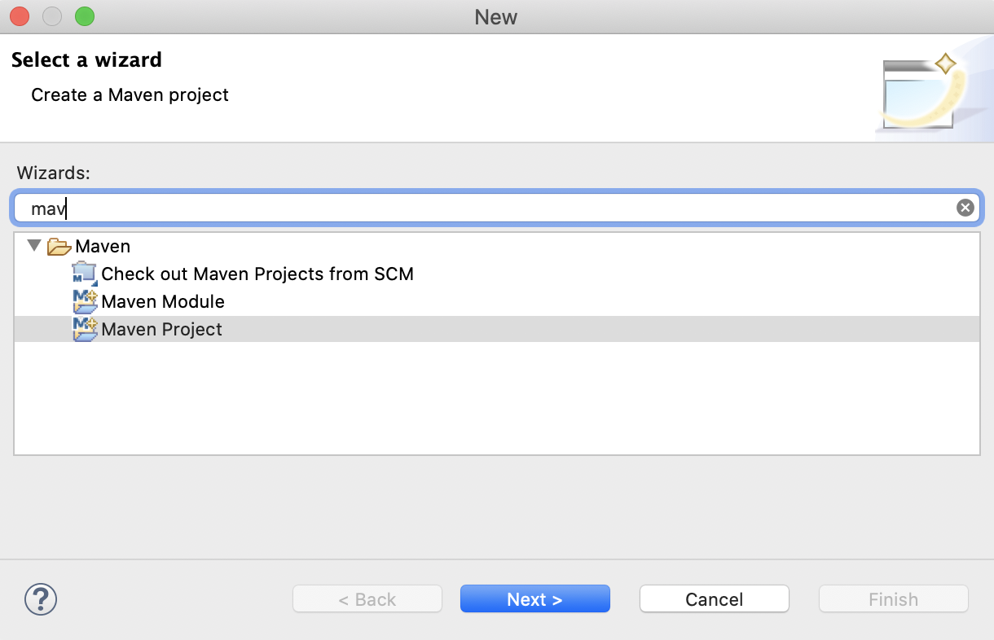

Hit the **Next >** button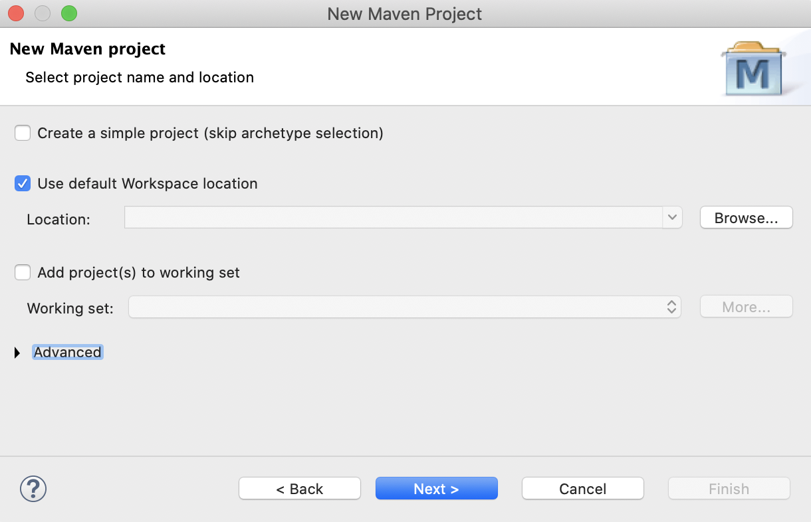

Hit the **Next >** button

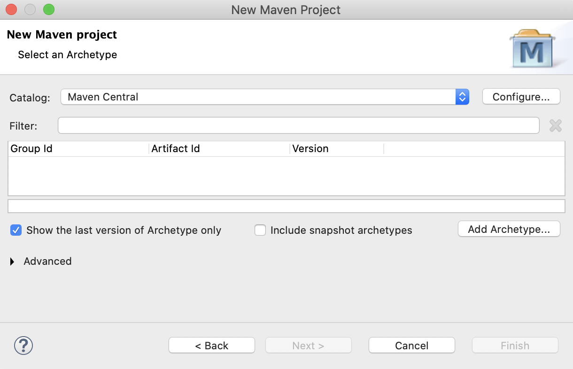

Hit the **Configure** button.

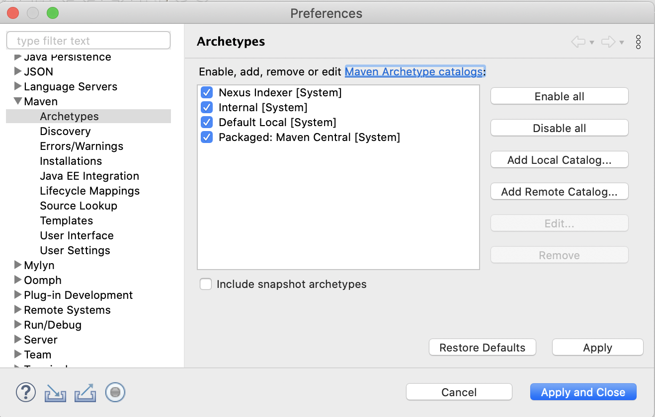

Hit the **Add Remote** Catalog button

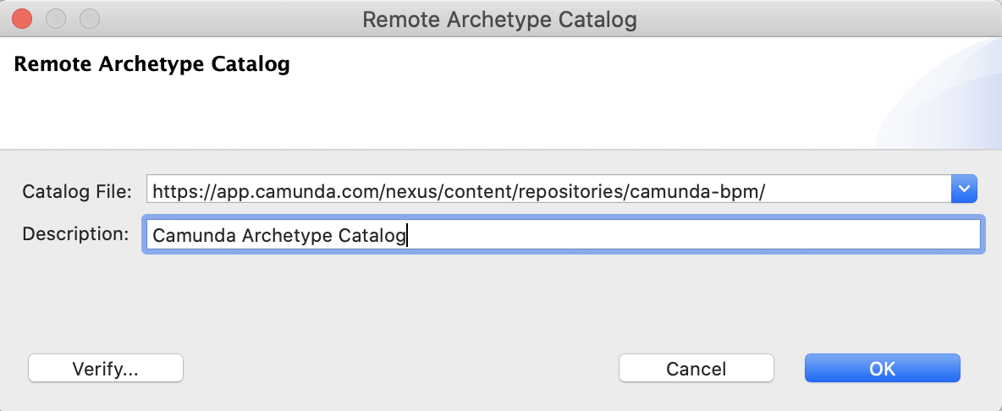

Add archetype catalog [https://app.camunda.com/nexus/content/repositories/camunda-bpm/](https://app.camunda.com/nexus/content/repositories/camunda-bpm/?__hstc=12929896.cddee92a584d5f140e89319c05c9729d.1595566596688.1598517889161.1598639214378.32&__hssc=12929896.2.1598639214378&__hsfp=1668083305)

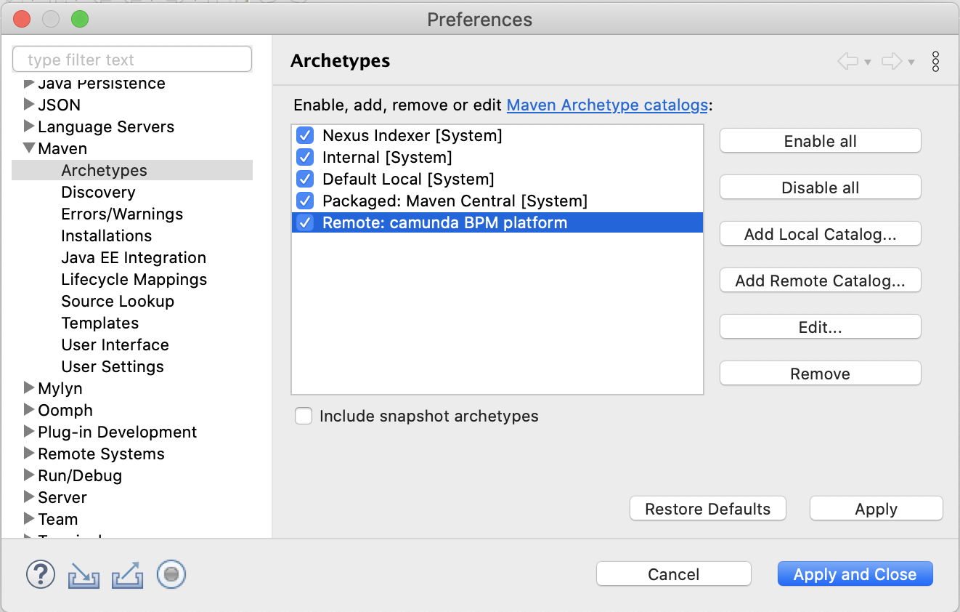

Hit the **Apply and Close** button.

Now you should be Now you should be able to use the archetypes when creating a new Maven project in Eclipse.

Lets verify Installed Maven Archetypes.

